

Virtual Internship

Data Science

Data Intake Report

Group Name: LISUM01: Data science Group 1

Members:

1. William Ogweli Okomba, Kenya

2. Ece Kurnaz, Turkey

3. Collin Mburugu, Kenya

4. Udbhav Balaji, India

Name: Bank Marketing(Campaign)

Report date: 23/07/2021

Internship Batch: LISUM01

Version:1.0

Data intake by: William Ogweli Okomba

Data intake reviewer: Intern who viewed the report

Data storage location: <location URL eg: github, cloud>

Problem statement

ABC bank (a Portuguese banking institution) has a term deposit product that is desired to be sold to clients. We will focus on customer's past interactions with the bank or other financial institutions to have a better understanding on whether these particular clients will buy this product or not. Developing a model with using machine learning for this aim is reasonable. With performing this project, our aim is to save resources and time for ABC bank.

Business Understanding

Project lifecycle

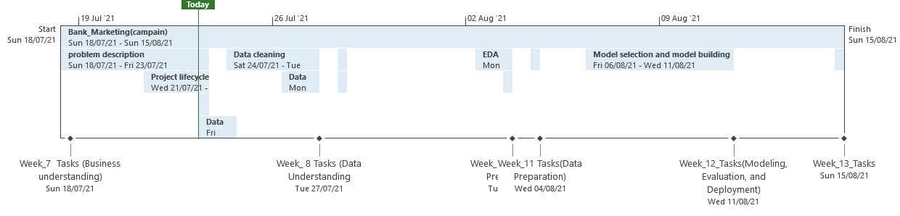

1. **File 1: Tabular data details:** **bank_additional_full.csv**

|  |  |
| --- | --- |
| **Total number of observations** | 41188 |
| **Total number of files** | 2 |
| **Total number of features** | 21 |
| **Base format of the file** | .csv |
| **Size of the data** | 5834924 BYTES(5.56MB) |

1. **File 2: Tabular data details:** **bank_additional.csv**

|  |  |
| --- | --- |
| **Total number of observations** | 4119 |
| **Total number of files** | 2 |
| **Total number of features** | 21 |
| **Base format of the file** | .csv |
| **Size of the data** | 583898 BYTES(572KB) |

**Proposed Approach of dedup validation (identification)**

1. Datasets do not specify the period which were collected.
2. There are 2 dataset, the second dataset is a sample of the first dataset.
3. There are 10 integers and 11 categorical variables.
4. The missing values in both datasets are presented by "unknown" string. We changed it to NaN.
5. There are missing values in six variables namely, job, marital status, education, default, housing, and loan. This will be imputed using various methods.
6. There are 12 duplicates in the first dataset and no duplicates in the sample dataset, this will be dropped since they are minimal and will not affect our analysis.
7. The target variable is unbalanced class, "no" class has more observation than "yes" class in both dataset.
8. Columns are not uniformed named for example "day_of_week", and "emp.var.rate". This need to be modified for make it easier to work with.
9. All variables in both datasets have the right datatypes.

**Assumptions**.

1. We assume the data provided is correct and up to date